
Coaching Handbook
HOW TO COACH A LIGHTWAVE GROUP
CONTENTS
1 Know why you are coaching 2
2 Be clear and intentional – the blueprint in your head 2
2.1 ALL INVOLVED 2
2.2 BECOMING DISCIPLES 3
2.3 CREATING COMMUNITY 3
2.4 DOING EVANGELISM 3
2.5 ENCOUNTERING GOD 4
3 Laying the Foundations to Coach 5
4 Coaching through the Stages of a Group’s Life 6
5 Helping Groups to identify their missional purpose 8
5.1 The Suffolk Discipleship Pathway (Coaching Tool) 9
6 Safeguarding THIS SECTION NEEDS UPDATING 10
6.1 Who is DBS checked? 10
6.2 How are DBS checks carried out? 10
6.3 What training is given? 10
6.4 Further Information 10
7 Linking a Group to Opportunities - Bishops, Communications, Diocesan Prayer and Resources 11
8 Training and Support for Coaches 12
9 Measuring Fruitfulness 13
9.1 Lightwave Group Coaching Form 14
10 APPENDICES TO BE COMPLETED 16
10.1 The Basis of the ABCDE values 16
10.2 Bibliography/ Resource List 16
10.3 Frequently Asked Questions – A Resource for Advocates 16
10.4 Contacts 16

How to coach a Lightwave Group

Know why you are coaching
Small group church involves more work for church leadership than models of church based on larger Sunday congregations. This is the reason why church based on small groups is not more popular. The most common reason for small group church to fail is lack of support for small group leaders. However, small group church is important because the intimacy of small groups has potential many more safe spaces for discipleship and leadership to grow – much greater than big church systems – more depth, more disciples, more leaders. Compared to training, coaching is much more effective in enabling fresh expressions of Church to thrive.
You are coaching in order to support the leaders of small groups in developing small groups which are effective in growing disciples and leaders by encouragement and the sharing of wisdom.

Be clear and intentional – the blueprint in your head
Of course, every group is different but it’s important to know about the things that do not change and intentionally coach towards them. The character of Lightwave groups is based on five key values:
- All Involved
- Becoming Disciples
- Creating Community
- Doing Evangelism
- Encountering God
These values are based on foundational Christian beliefs (See appendix 10.1). As a group learns to live by these values, they will become visible and embodied through the practices, habits and structures of the small group.
You can find discussion starter videos for each of the values here: https://lightwave.community/core-values

ALL INVOLVED
This value comes out of the belief that God is for everyone, every single person is precious to Him and that he gives to each person gifts to serve and insights to share.
Coach towards the group being strongly participative.
When you visit the group, you can see this value in action if you hear the voice of everyone in the meeting. The leader’s voice will not dominate if the group belongs to everybody.
The small group leader can encourage the development of this value in the group by embodying in the structure of a regular meeting of the group. Every week can begin with a time of Welcome when everybody in the group answers a simple unthreatening question (usually connected to the focus of the meeting), e.g. “What did you do at the weekend?” or “What is your favourite food and why?” Once everyone’s voice has been heard at the meeting, it is much easier for them to speak again so this is especially good for new or less confident members.
It is also good for the leader to develop a expectation that a different person leads a different part of each meeting in – and this enables leadership and collaboration to grow.

BECOMING DISCIPLES
This value comes out of a belief that Jesus calls us to follow him and to grow in faith and love.
Coach towards the group intentionally helping each other to grow in deeper discipleship.
When you visit the group, you can see this value in action if you see the group worshipping, praying and studying the bible – and especially look for them to have an emphasis on applying the things they are learning from the bible in their lives and seeking to have accountability with each other.
The small group leader can encourage the development of this value in the group by embodying it in the regular pattern of the group meeting:
- WORSHIP – the group worships (adoration)
- WORD – the group studies the bible and prays for each other about the application of God’s word in their lives
- WITNESS – the group engages in listening prayer, the group prays for help and guidance in its own evangelism and mission, the group prays for wider issues and people in need

CREATING COMMUNITY
This value comes out of a belief that God has made human beings to be most fulfilled in community and shared lives – loving and working together. Jesus told us to love our neighbour as ourselves – both the neighbour who shares our faith and the neighbour who doesn’t.
When you visit the group, you can see this value in action if the group members care for each other and act together to build community with others beyond the group.
The small group leader can encourage the development of this value in the group by encouraging the group to engage in activities together where they work as a team. For example, running a village fun day, organising a litter-pick or packing shoe-boxes with Christmas gifts for refugees.

DOING EVANGELISM
This value comes out of not only Christ’s command to be his witnesses but also especially the command to love. Good evangelism comes from being big-hearted. When we value God highly and value other people highly, we cannot but be motivated to share the good news of God’s love.
When you visit the group, you look for this value to be expressed
- In prayer for help to love others
- In planning and praying for outreach activities with care and intentionality
- In people coming to faith through the group
- In a hospitable spirit to invite and welcome new people into the group or a fresh expression of Church which the group runs.
The small group leader can encourage the development of this value in the group by
- Making regular time for the group to pray that their love for others might grow
- Leading by example in sharing their faith and welcoming people who do not yet believe
- Making opportunities in the group for group members to rehearse with each other what they would say if asked difficult questions relating to faith (The Talking Jesus Course is a Good Resource for this)
- Leading the group to identify its main vision for mission (see page 8, below)
- Ensuring that the group plan and personally invite people to activities which give of themselves to be a blessing to people who do not yet believe (e.g. a filmnight, help with gardening or organising a community event) and some opportunities for people to actively explore Christian faith (e.g. Alpha or a fresh expression of Church). The Sowing, Nurturing, Flowering, Fruit model is a helpful tool for this (see page 9 below)

ENCOUNTERING GOD
This value comes out of a belief that it is God who is working in us – everything we do comes from the work of his Spirit in us.
When you visit the group, you can see this value in action where worship and listening to God and prayer flow through the meeting. There is an expectancy that God will speak to and work through the group. This does not involve one brand of spirituality so could be expressed very differently in different groups.
The small group leader can encourage the development of this value in the group by giving priority to worship (remembering God’s greatness) and by always seeking to “pray in” what the group is learning. As needs are shared, the leader can encourage it to be normal in the group to stop and pray for those things. When you pray, make sure you give time for God to speak.

Laying the Foundations to Coach
In your initial meeting with a prospective coachee small group leader, find out what they most want from coaching and gain permission from them for the level that they will let you coach. Here are some questions which you should explore and some guidance notes on each:

QUESTION | NOTES AND SUGGESTIONS
What would you like to get out of having a coach? | Share the general purpose of Lightwave coaching too as well as what you personally feel you can offer. Lightwave coaching is in order to support the leaders of small groups in developing small groups which are effective in growing disciples and leaders
How often do you want to meet – and how? | Suggest monthly for face to face or skype – This might be quite informal over coffee… quality time to build the relationship. In between you can text to say you are praying for them – or ask for prayer requests.
What areas would you find most helpful to talk about together? | Key areas for coaching:  - How to create light leadership (to facilitate participation)  - Establishing mission goals as a group.  - Facilitating spiritual growth  - Overlapping with the above - establishing the values – All Involved Becoming Disciples, Creating Community, Doing Evangelism, Encountering God  - Discipling new Christians  - Moving through the stages of development of a group  - Difficulties with people and group dynamics  - Training needs  - Exploring vocation  - Keeping the leader’s passion - resilience and selfcare in ministry  - Establishing safeguarding good practice as a given
When/how often should I visit the group and what should that be like? | When you get small group leaders together, they benefit from networking but you don’t learn a great deal about what is really going on – you need to visit the group as well as meet with the leader. Sometimes the leader may invite you in to do a piece of work with the group – but mostly, it is suggested you do and join in like a normal member – but observing carefully so that you can give the leader helpful feedback especially if they want you to advise them on handling particular situations in the group.
How would you like the diocese to gather data about the group? | The diocese needs to gather data (e.g. numbers in group, frequency of meeting, numbers as fresh expressions) so that we can learn what’s working well and increase good practice. We will do this as much as possible using ChurchSuite but it would also be normal for the coach to be able to pick up this information as they coach and this will save extra form filling and administrative phone calls. However, there may occasionally be a reason why your coachee wants to keep this data-gathering separate from their coaching experience.

Coaching through the Stages of a Group’s Life
STAGE |  | Input from Lightwave Community Team or coach
Enquiry |  | - Identify planting team – e.g. through  - Lightwave introductory course  - MSM central course  - recommendation of incumbent  - direct enquiry  - Offer training & support of a coach
Forming  - Group establishes their shared values, leadership structures and rhythms of life including praying together  - Group clarifies their sense of vision – to whom are they being sent (e.g. people in a geographical area, connected by a common interest or network of relationships) and what are the needs of these people and connecting points with the Team  - Group forms relationships with each other |  | - Lightwave course or training day helps team leaders to think through shared values, leadership structures and rhythms of life.  - Coach may offer Gray matrix and Suffolk Discipleship Pathway model to discern how to offer contacts opportunities to take steps in their faith journey.  - Coach helps leaders to understand the lifecycle of small groups so that storming does not take them by surprise.  - Coach encourages social events to help relationships to be established.
Storming  - In this stage group members are working through differences to clarify expectations, style and desired purpose. There will be some conflict and sometimes leadership is challenged, or people leave.  - Many groups find this stage difficult or unsettling. |  | - Coach helps leader to understand differences in the group and how to facilitate understanding between them.  - Advice is given to focus on worship, placing God at the centre of group’s attention.  - Advice is given to reaffirm missional purpose of the group.  - Coach likely to visit group to reassure group and support/advise leader.
Norming  - This stage is typically characterised by a strong group identity, harmony, respect, intimacy, trust, loving accountability  - There is a danger of Become over-comfortable leading to stagnation/resistance to change  - In terms of the Suffolk Discipleship Pathway model, Sowing/ Nurturing will include developing relationships through social events and acts of service and giving time to getting to know individuals who are interested in connecting with the group and/or exploring faith. It will involve some events which contain some Christian content which make it easier for people to start conversations about spiritual things. |  | - Coach reinforces missional values and helps leader to:  - Reaffirm missional purpose of the group  - Minister to and with one another  - Equip members for ministry  - Develop leadership  - Facilitate outreach  - Apply Suffolk Discipleship Pathway model to their opportunities
 | Performing  - This stage is typically characterised by good teamwork, Group ownership, growth of ministries, people beginning to join group and/or planting a fresh expression of Church.  - In terms of the SNFF model, sowing & nurturing continues as above but flowering and fruit is also seen: Flowering is offering the opportunity for people to learn more and to respond to Christ –  - e.g. alpha course, local mission event. Fruit will normally involve somebody joining the small group or another regular expression of church and learning to engage in spiritual disciplines such as prayer, bible-reading, service, financial giving and mission. | Coach helps leaders to lead in the planting a fresh expression of Church and/or to engage the group in facilitating flowering and fruit stages of the lifecycle by organising outreach events and opportunities for witness.  Coach helps the group leaders to:  - Challenge group members to further individual growth. Delegate leadership more and more to growth of new leaders.  - Adapt for increased membership and/or prepare to plant a new Lightwave group  - Find appropriate training for the leaders merging in their groups (e.g. MSM).
 | Re-forming  - Within the small group, members grow in discipleship and leadership and after two or three years leaders may be able to hand on to new leaders or people.  - The group may need or reform because leaders are moving on to start another missionary endeavour.  - Or they may reform simply to accommodate new members. | The Lightwave Community team and coach helps the group to celebrate all that is good in the past work of the group and to work through any sense of grief/ loss at the changes made to a close-knit group. Begin again.

Helping Groups to identify their missional purpose
Helping a Lightwave Group to identify and fulfil their missional purpose is key for the fruitfulness of a Lightwave Group and any fresh expression of Church which it plants. The purpose of a Lightwave Group needs to be both missional and ecclesial - in other words a Lightwave Group seeks to be church for its members, helping them to grow in discipleship. It also seeks to emphasise the “sent” nature of being a disciple and aims to share the gospel through its everyday life together, making new disciples.
You can help a Lightwave Group to identify its own special missional purpose by encouraging them to follow the following practices:
- Value: Work on placing a high value on not-yet Christian disciples and introducing them to Jesus e.g. by studying Jesus’ teaching and example of “seeking and saving the lost” in the gospels.
- Pray: Pray for God’s Kingdom to come in the sphere of influence of the Lightwave Group members. Pray for individuals for blessing on them and their situations, for blessing on relationship with them, for them to encounter God.
- Be intentional: Lightwave Group members plan to deepen their relationships with, prayer and witness to those who are not-yet-Christian disciples and hold each other accountable for these intentions. They will think about their witness in terms of the Sowing, Nurturing, Flowering, Fruit model shown below.
- Build relationships: The Lightwave Group will plan together social events which build community with church and non-church friends together.
- Being a blessing: Through listening to friends and neighbours and considering the gifts and abilities of existing group members, the Lightwave Group identifies a way or ways of being a blessing to their friends and neighbours, usually around a special interest which provides a way to deepen community with those who are not yet part of any church - a “nurturing” activity. Examples of this might be crafting club, a walking group, running a cafe or monthly cafe church, mending cars, offering odd job help, visiting a care home, running a parent and toddler group. Some teams will become a fresh expression of Church in themselves by including new Christians within the group. Others may act as missional teams for a distinct fresh expression of Church.
- Creating opportunities for steps of faith: The Lightwave Group explores the question - what will help our Lightwave Group friends to become a disciple of Christ? They then create or look for such an opportunity (a step in the Suffolk Discipleship Journey Model). Examples could be running a mini alpha course or attending a larger one with friends, a hot-potatoes evening (with opportunities to ask really difficult questions about faith) or a special focus on discipleship at the cafe church or messy church which the Lightwave Group supports.
- Inviting friends who are seeking to join the Lightwave Group and or a fresh expression of Church it regularly leads: This may mean adapting some activities for a season to make a Lightwave Group more easily accessible to newcomers and those who are seeking faith. Where local expressions of Church are monthly (which is common for many fresh expressions of Church such as Messy Church and for parish churches in many multi-parish benefices), the Lightwave Group provides a way to explore deeper discipleship beyond the monthly gathering and provides closer community as the context for growth in discipleship.

The Suffolk Discipleship Pathway (Coaching Tool)
The Suffolk Discipleship Pathway (see picture below) is a way of describing the steps that most people take on their way to discovering and growing in faith. It helps churches and small groups to think about how they can provide stepping stones to faith for the people they are in contact with.
There is a powerpoint resource which gives more detail called Suffolk Discipleship Pathway Workshop. Download from www.lightwave.community/resources

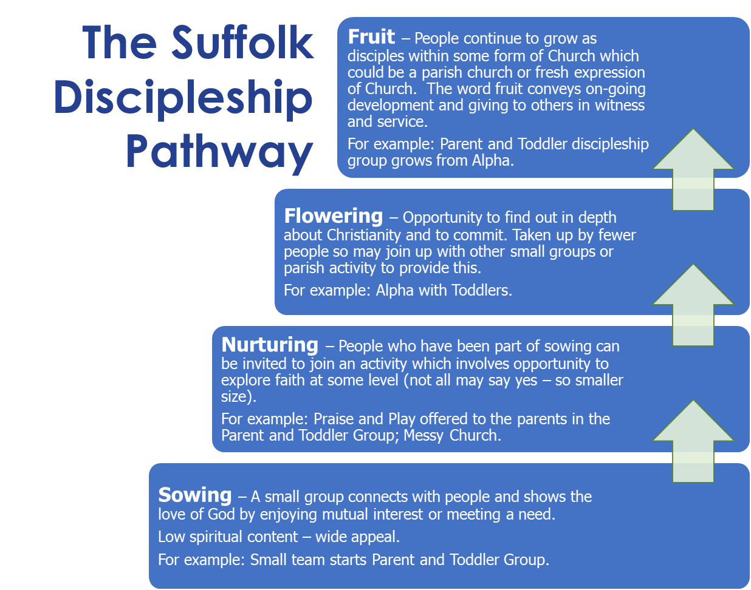

Safeguarding THIS SECTION NEEDS UPDATING
The Lightwave Community follows the Diocesan Guidelines for safeguarding https://www.cofesuffolk.org/safeguarding
The Lightwave Community has adopted the diocesan comprehensive Safeguarding Policy and our volunteers who lead work with children or adults (or both) are DBS checked or are in the process of being checked and also receive Safeguarding training as outlined below

Who is DBS checked?
All Lightwave Group leaders are required to be DBS checked with roles clearly defined as to whether they were working with children or adults or both.
In addition, leaders of any activity the group is running should have a DBS check. Depending on the nature and who is attending the activity, there are rules as to whether or not we can/need to do a DBS check and so each activity will need to be reviewed regarding the eligibility requirements of the DBS criteria. If in doubt, please contact andrew.gosden@cofesuffolk.org in the first instance.
IMPORTANT NOTE: Lightwave groups associated with their PCC will need to be checked through the normal Parish Church process by contacting their Parish Safeguarding Officer. Training can still be provided through Lightwave – see below.

How are DBS checks carried out?
A number of administrators/managers can facilitate the DBS checking process:
- Diane Grano (diane.grano@cofesuffolk.org) for Lightwave groups associated with the Red Lodge Rural Resourcing Church
- THIS SECTION NEEDS UPDATING
- If in doubt contact Andrew Gosden – andrew.gosden@cofesuffolk.org for more information

What training is given?
All Lightwave group leaders are required to complete the Leadership training module.
All group members are encouraged to complete foundation training. This can be done online, but the preference is for training to be undertaken as part of a group meeting, and the Lightwave team can facilitate this. Anyone who misses face to face group training is encouraged to complete the training online.

Further Information
We review the Safeguarding Policy and our safeguarding practice each year.
If you have any concerns at any time about safeguarding in the Lightwave Group or Rural Resourcing Church please contact the Archdeacon for Rural Mission, Sally Gaze – archdeacon.sally@cofesuffolk.org or use the link below to report your concern directly.
https://www.cofesuffolk.org/safeguarding-contacts
Further useful information can also be found at the link below
https://www.churchofengland.org/safeguarding/promoting-safer-church-safeguarding

Linking a Group to Opportunities - Bishops, Communications, Diocesan Prayer and Resources
It is great for Bishops to visit Lightwave group and hubs. Please arrange an episcopal visit asap through Sally Gaze: archdeacon.sally@cofesuffolk.org
Becky Luetchford is our Communications Missioner. She is seeking to help groups (especially rural groups) share what God is doing through film and story so we can all be encouraged and learn from each other. Please make a date for her to come to your group sometime in the next 12 months – do not wait for something spectacular any of the following would be valuable – or suggest your own idea:
- The faith story of someone who has recently come to faith
- The story of someone exploring their vocation
- The story of a group just starting out – their hopes, fears and prayer requests
- The story of a more established group and what God has done through you
- An mission event or activity your group are involved in
- The story of something a Lightwave group is learning about God’s ways
Becky can be contacted on becky.luetchford@cofesuffolk.org, mobile: 07812 632154
Nina Seaman is our Prayer Coordinator. She sends out a monthly prayer letter and it would be great if a request from your group could be included at least every couple of months. She also likes to meet with people from groups to get a deeper idea of their prayer needs and thanksgivings. Fridays 9-54is her best time for this, but it is worth asking if she is free at other times too. Nina can be contacted on nina.seaman@cofesuffolk.org, mobile: 07394 559889
The Lightwave Community has a website including a range of resources (still being uploaded at the time of publication.) Please encourage your groups to go to
www.lightwave.community/resources to find small group ideas, activities, meeting outlines, bible studies, film clips, stories and more.

Training and Support for Coaches
- Sally Gaze offers the main support for coaches with Diane Grano also taking on the support for coaches in West Suffolk.
- Leaders of Huns coach the first group leaders in the hubs and go on to develop other coaches to work alongside them
- As the number of coaches grows, structures of support and training will need to adapt.
- Training dates can be found at https://lightwave.community/support-training or seek training at a time convenient to you by emailing lightwave.community@cofesuffolk.org
- For help ring Sally on 07446 933129

Measuring Fruitfulness
As the planting of Lightwave is part of an externally funded project, we are required to report on progress towards the project goals of making 1500 disciples in 60 small groups. However, reporting and tracking needs to be done in a way which is helpful and supportive for the groups themselves – so that groups are learning from each other what works well and so that we identify early where a group may need more support, training or resource.
Support starts with a group applying to become a Lightwave group. You can find the latest application form and guidance notes: https://www.lightwave.community/resources/lightwave-community-membership-benefits
The reporting form below is designed to encourage coaches to find out the things helpful for your coaching. If you are able to provide information on behalf of the groups you coach, it will mean that they do not also need to supply this to the Project team
- Activities at Project Level – e.g. giving a group a coach, group running a training event (Checking what we are doing as a diocese)
- Lead indicators at group level are observable changes or behaviours that suggest that our activities are leading towards the ultimate change we want –e.g. a group meeting weekly, developing the ABCDE values, deciding their mission focus
- Ultimate outcomes are the observable changes or behaviours that show we are growing - setting up a fresh expression of Church primarily for people who are not part of any other church, number of people becoming disciples for the first time.
The value of this system of measuring is that it enables Lightwave to test our assumptions about how change happens. If we see that our activities are not leading to the leading indicators, or that these are not translating into ultimate outcomes, we know to question what we are doing and see what God may be saying to us about changing this. The system is therefore primarily designed to help you and us to monitor, learn and improve.
Please could you fill in the form below each month after chatting to the leader you are coaching or after a visit to the group. It is probably better not to fill in the form at the group or with the leader as they could lead to too much formality - let the conversation flow freely and put the people before the form.

Lightwave Group Coaching Form
BASIC INFORMATION
Complete the details for the group or groups you are coaching
Name of Group |  |  | Enrollment Form Returned | y/n
Leader 1 & Contact details |  |  | Incumbent Consulted | y/n
Leader 2 & Contact details |  |  | BMO Board Approval | y/n
Safeguarding Training (specify who and which courses) |  |  | Working under PCC or BMO (Please specify) | PCC/BMO
Safeguarding Representative
Name of Coach

COACHING RECORD
Name of Group _______________________________ Venue _______________________ Group Meets (Time, Day, Frequency) _______________
Date of Record _____________________________________
 | Stages/ Milestones in Group Development
DATE | Initial Enquiry | Leader  Training | Forming | Regular  Meeting  Established | ABCDE  Estab’d (See below) | Mission identified | Mission events | Contacts group is praying for | fxC Started monthly | Nos attending fxC
 | Y/N | Y/N with narrative if required | Y/N | Y/N and how often | Y/N with narrative | Y/N | Examples | Y/N and names if appropriate | Y/N | Numbers

Date of Comments | Comments on Values and Score out of 5
Date of Comments | All Involved | Becoming Disciples | Creating Community | Doing Evangelism | Encountering God

APPENDICES TO BE COMPLETED

The Basis of the ABCDE values

Bibliography/ Resource List

Frequently Asked Questions – A Resource for Advocates
See separate document on www.lightwave.community/resources under Lightwave Documents

Contacts
Sally Gaze | Archdeacon for Rural Mission & Leader of Lightwave Community | archdeacon.sally@cofesuffolk.org | 07446 933129
Diane Grano | Associate Leader of Lightwave Community & Leader of Red Lodge Lightwave Hub | diane.grano@cofesuffolk.org | 07403 210793
Andrew Gosden | Project Manager | andrew.gosden@cofesuffolk.org | 07711 753312
Becky Luetchford | Communications Missioner and Missional Storyteller | becky.luetchford@cofesuffolk.org | 07812 632154
Nina Seaman | Administrator and Prayer Co-ordinator | nina.seaman@cofesuffolk.org | 07394 559889
Danny Doran-Smith | Lightwave Minister on Secondment Lead on Financial Sustainability & LoveRural | danny.doransmith@lightwave.community | TBC

